Name:  Teacher : | ____________________________________  ______________________ |  | Date:_________
 | Year 10 General  SCORE:  /47  Mini Test 6  Topic – Trigonometry  Full working out MUST be shown to get full marks for each question.
Total Time: | 55 minutes
Weighting: | 5%
Equipment: | To be provided by the student: Pen, pencil, ruler, scientific calculator, 1 single sided page of A4 notes

Q1) Find the missing side length using Pythagoras theorem [2 + 3 = 5 Marks]

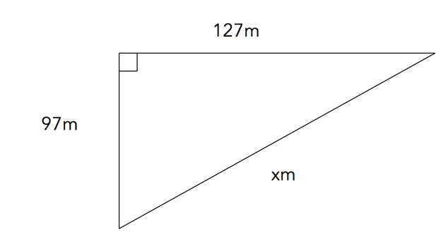

b.
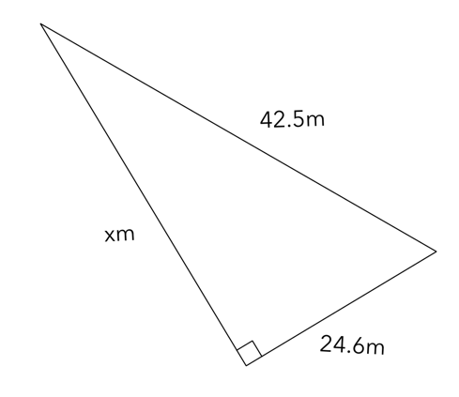

Q2) Jasmine and Jess want to build a patio in their back yard. They need 2 diagonal beams to act as stretchers. The patio is a rectangle that is 6m wide and 8m long. How much wood do they need for their frame? hint- draw a diagram of the scenario. [5 Marks]

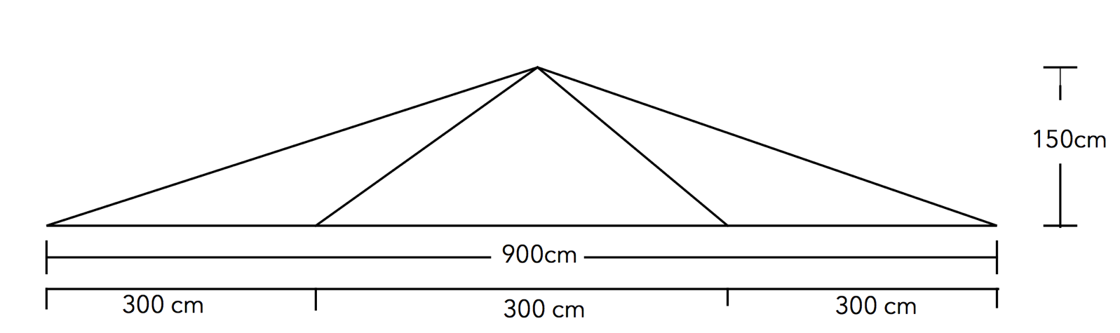
Q3) Jasmine and Jess continue to build out their house, by extending the roof. Jasmine designs the following structure for roof support. It is 150cm tall, and 900cm wide. If they need three of these supports for the roof, how much wood do they need to order for this extension? [6 marks]

Q4) Label the triangle below using theta as a reference angle. [3 Marks]

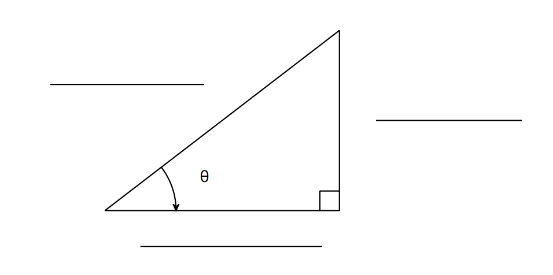

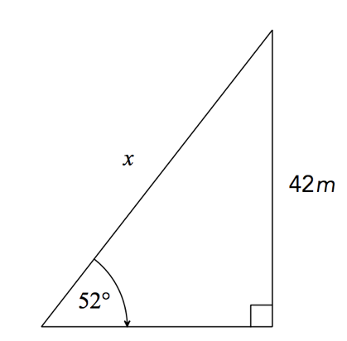
Q5) Find the values of the missing side lengths. [3 + 3 + 3 = 9 marks]
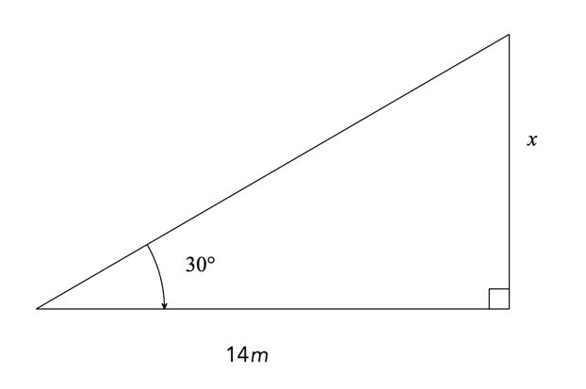

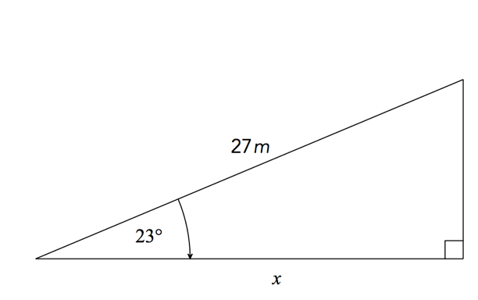

Q6) Find the value of theta in the two triangles below [3 +3 = 6 marks]

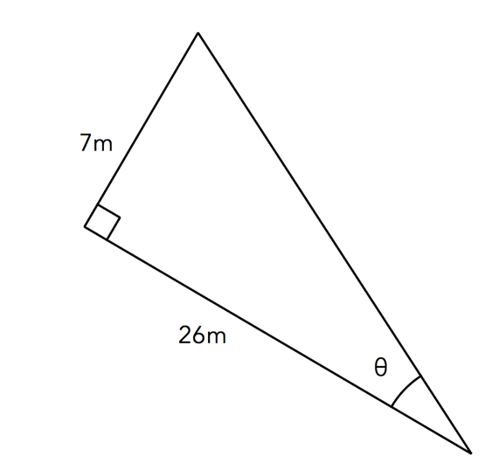
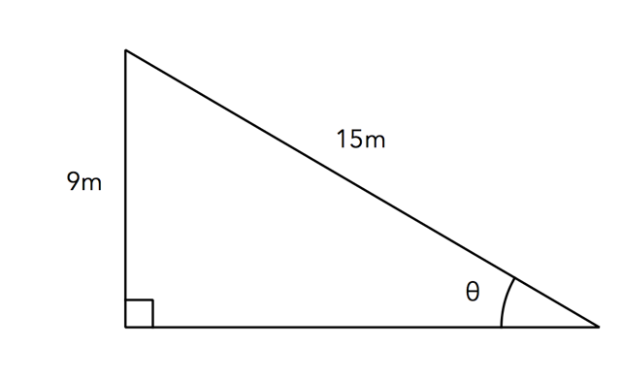

Q7) Hallee and Ashlee go camping. They park their car 20m away from the trunk of a tree. the use an inclinometer to measure that the angle of elevation from Ashlee’s eye is 62 degrees. Ashlee is 150cm tall at eye level. Is their car in a safe spot if the tree were to fall over? [5 marks]

Q8) Matt, Will and Keiren go mountain climbing. They first walked 1.5 km along a path inclined at an angle of 10° to the horizontal. Then they had to follow another path, which was at an angle of 20° to the horizontal. They walked along this path for 1.3 km, which brought them to the edge of a cliff. Here, Keiren spotted a large gum tree 1.4 km away. If the gum tree is 150m high, what is the angle of the depression from the top of the cliff to the top of the gum tree? [8 marks]
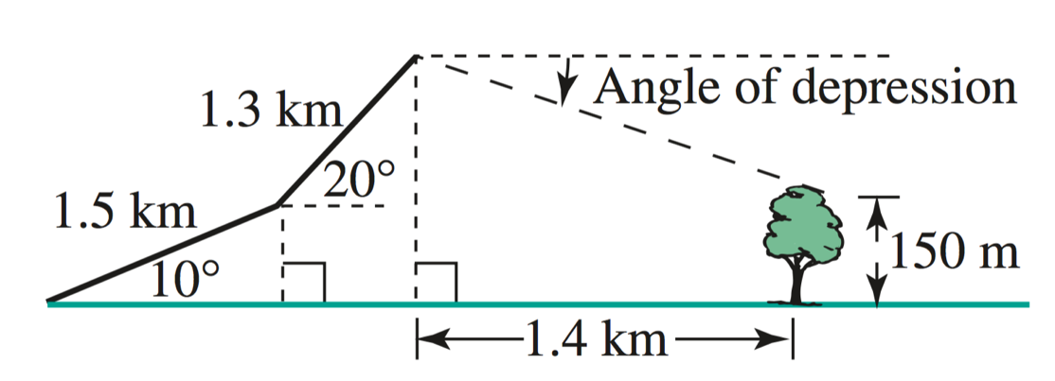

~End of Test~

